Classroom Procedures
- BELLRINGER: Students will ALWAYS come in and work on the Bellringer; when finished, take out the Work Packet / ThinkSheet from the previous lesson’s homework.
  - Current Events
- MR. B CLASS WORDS: PLEASE, THANK YOU, YET
- When I Ring the Bell or say “OKAY!” you have 5 seconds to finish conversations.
  - Not enough time? Say, “I’ll finish telling you later.” Done.
- Class Partner: You will be assigned to a partner twice per trimester (6 partners throughout the year.) It would be wise to be respectful and helpful to each partner you have throughout the year. There are many opportunities that will arise where it would be advantageous to have a partner you can communicate with efficiently.
  - If you are absent and miss the NOTES for a lesson, you should ask your partner if you can copy them first thing when you get back to class.
  - I may allow you to work with your Partner during Homework Start or occasionally… on QUIZZES.
- Homework Start: I will always try to give you 10-15 minutes at the end of class to start your homework
  - May be more on some days, others it just won’t happen (SORRY) but it all evens out
  - Sometimes you will have time to finish, but don’t expect to
  - I will use this time to work individually with you if you have any questions or need help understanding something
- Lesson Rating: Around the time that we put away our IPads before the bell, I will occasionally ask all students to rate their understanding of the day’s lesson. You should have a good idea after Homework Start time.
  - The Lesson Rating procedure is VERY important! It provides:
    - Self-assessment: it will help you identify where you are at, and maybe if you need to seek assistance
    - Planning: it helps me figure out how we are doing and who needs more time and practice with the lesson concepts
- ABE: ABE is our official weekly agenda
  - M-F assignments and important dates will be up on ABE every Monday.
  - You will fill out the entire week and important dates in your assignment notebook on MONDAY
  - Absent? Forget your assignment notebook somewhere?
    - ABE will be posted to our class website every week on Monday.
- Class Number: Each student will have their own number (based on alphabetical)
  - WRITE THESE DOWN IN MULTIPLE PLACES – folder, notebook, syllabus, AN, Companion
  - Mainly for turning assignments into A-Z (collator) and collecting graded work
- STEP System: Remember, these don’t reset until the END of the TRIMESTER
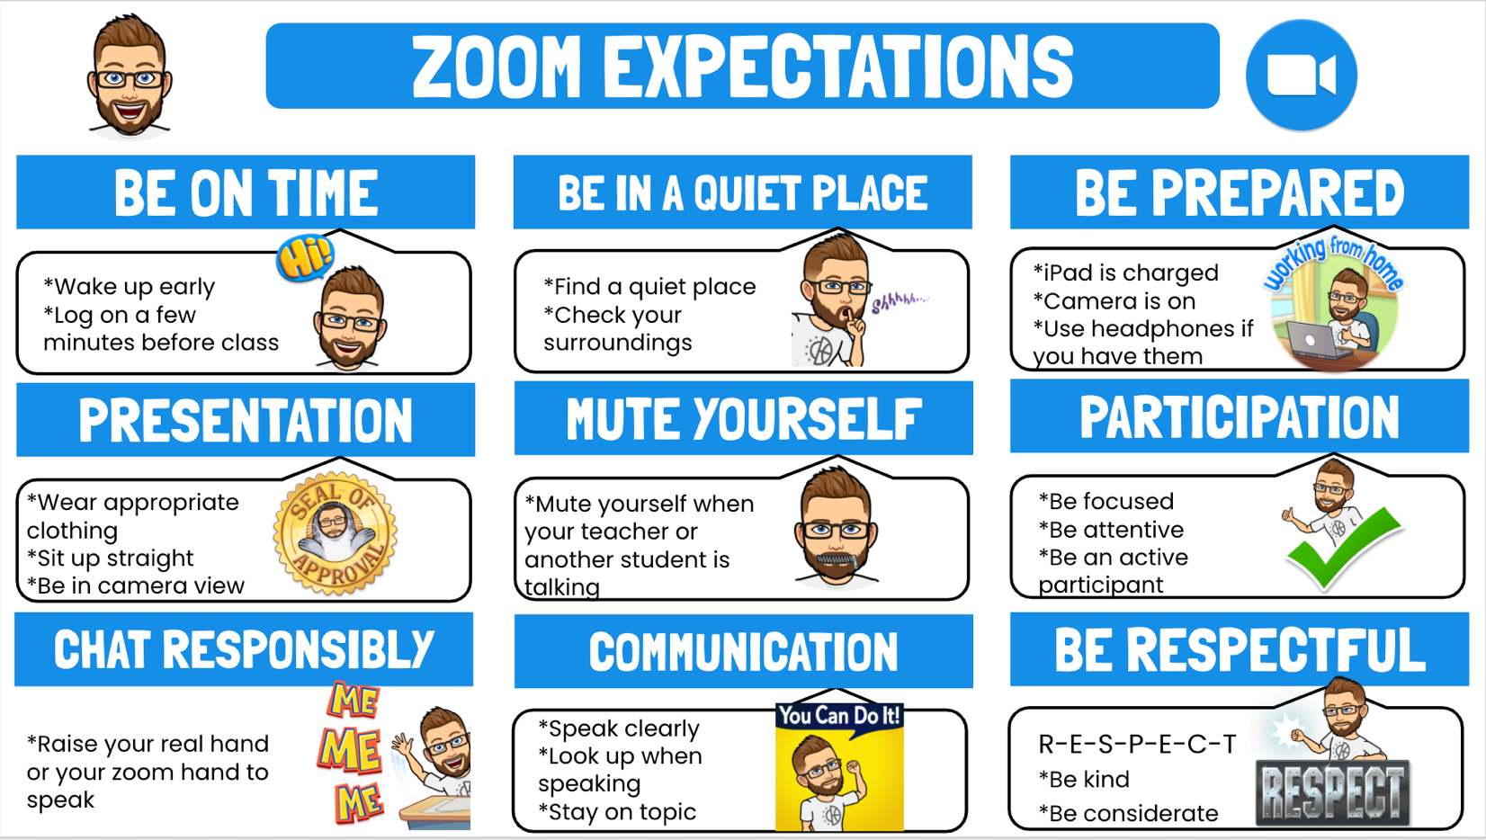

If you are having tech issues at home, email the NLSD122 Tech Department: tech-help@nlsd122.org

