Everyday Mathematics
Unit Five
Fraction and Mixed-Number Computation;
Measurement

Everyday Mathematics students are expected to master a variety of mathematical concepts and skills over time. The curriculum frequently revisits topics, concepts, and skills that are aligned with the Common Core State Standards for Mathematics. For this reason, the written assessment includes items recently introduced as well as items that assess long-term retention and mastery.

Content assessed:
- Decompose, or break apart, fractions
- Add and subtract fractions; solve number stories involving fractions
- Add and subtract mixed numbers
- Create a line plot and answer questions using the data
- Identify types of rotations and angles
- Identify and draw lines of symmetry
- Draw the matching part of a symmetrical shape
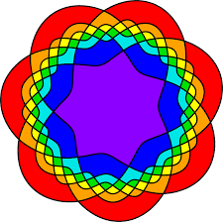
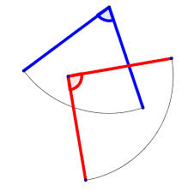
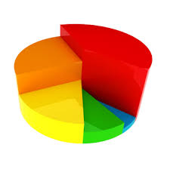
- Explain mathematical thinking clearly and precisely

