Everyday Mathematics
Unit Six
Division; Angles

Everyday Mathematics students are expected to master a variety of mathematical concepts and skills over time. The curriculum frequently revisits topics, concepts, and skills that are aligned with the Common Core State Standards for Mathematics. For this reason, the written assessment includes items recently introduced as well as items that assess long-term retention and mastery.

Content assessed:
- Solve extended division facts
- Divide numbers using partial quotients
- Interpret remainders in division number stories
- Measure angles and identify types of angles
- Calculate missing angle measurements
- Convert between tons, pounds, and ounces
- Solve number stories involving fractions
- Find the length and perimeter of a rectangle given the area
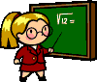
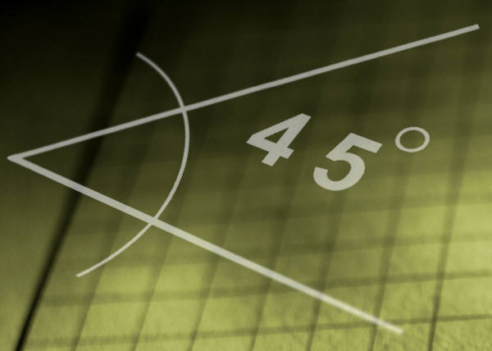
- Explain mathematical thinking clearly and precisely

