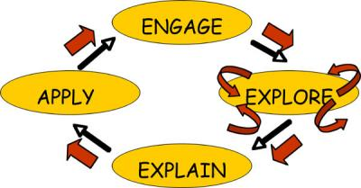

1. You will be given a partner to work with for this project.
2. You and your partner will go to the following 5 websites to look at the
pictures:
NOTE: Your teacher will be walking around the room helping each
group with the computers and being a facilitator for the assignment.
Tigar- http://kids.nationalgeographic.com/kids/animals/creaturefeature/tiger/
Giraffe- http://kids.nationalgeographic.com/kids/animals/creaturefeature/giraffe/
Crocodile- http://kids.nationalgeographic.com/kids/animals/creaturefeature/nile-crocodile/
Skark- http://kids.nationalgeographic.com/kids/animals/creaturefeature/sand-tiger-shark/
Panda- http://kids.nationalgeographic.com/kids/animals/creaturefeature/panda/
3. You will write out a list of the animals that you saw on each website
and whether you think it survives by eating meat or plants. If the animals
teeth were notshown in the picture, look at the picture closely for other
clues and make your best guess. You will also write down why you came
to the answers that you did. If you and your partner do not agree, write
that down and say why.
4. After you have been to each site and have decided whether or not each
animal is a plant eater or a meat eater, you will prepare to stand in front
of the class and share your opinions. Every team will get a chance to
share their opinions.
5. After every group has shared, the teacher will go over the correct
answers with you and explain why that animal is a meat eater or a
plant eater!
6. Once all of this is complete, your day as scientists in the wild will be
over until it is time to investigate something else new and exciting!

