How to Make Spelling Fun!
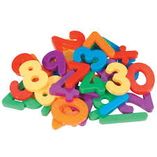
- Use magnetic letters on a refrigerator or cookie sheet to spell words.
- Cut out letters from a newspaper or magazine to spell words.
- Call out spelling words in the car.
- Spell words with glue and sprinkle glitter on them or use glitter pens.
- Got a Magna Doodle? Write your spelling words on it!
- Write words in sand or shaving cream.
- Write spelling words in bubble letters.
- Use ABC cookie cutters and play-dough to cut out letters to spell words.
- Paint spelling words

Websites:
- SpellingCity.com
- Kidsspell.com
- AAAspell.com

