Background Information
The Great Chicago Fire was a conflagration that started around 9 p.m. on Sunday, October 8, 1871. It is believed that that the fire started by a cow kicking over a lantern in the barn owned by Patrick and Catherine O'Leary, however, there are no specific sources that confirm that report. The Chicago Fire Department did not receive the first alarm until 9:40 p.m., but by that time the fire was burning wildly through downtown Chicago. In the early morning hours of Tuesday, October 10, 1871 the fire extinguished due to a light rainfall, but by that time the damage was already done. A stretch of Chicago that spread four miles long and 3⁄4 mile wide was completely destroyed by the blaze. At least 300 people were killed and more than 100,000 were left homeless. In addition, the fire caused more than $200 million worth of damages to homes and businesses.

*Now that you know some facts about the Great Chicago Fire of 1871, it is your job to determine what exactly caused this tragedy to occur.
*After viewing each clue, write down a description of the clue.
*After all clues have been analyzed, write a conclusion to what you believe made the Chicago Fire worse than any fire in the 19th Century. (minimum of 4 sentences)

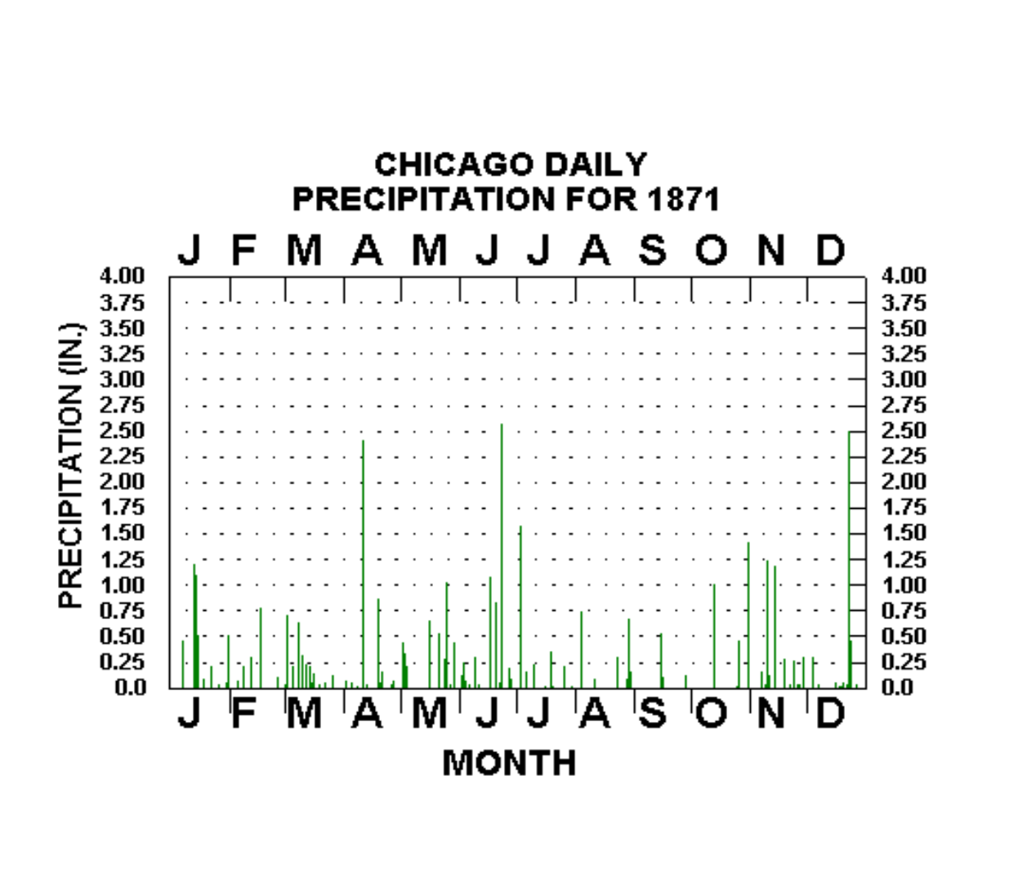
Clue #1 “Dehydration”

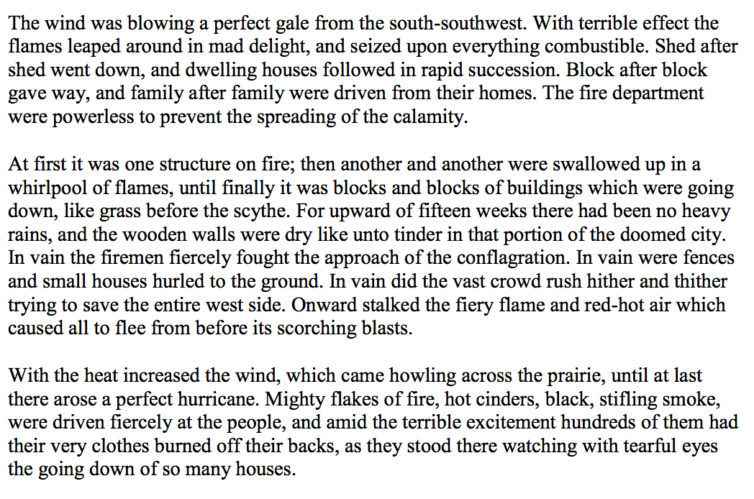
Clue #2 “The Wind”

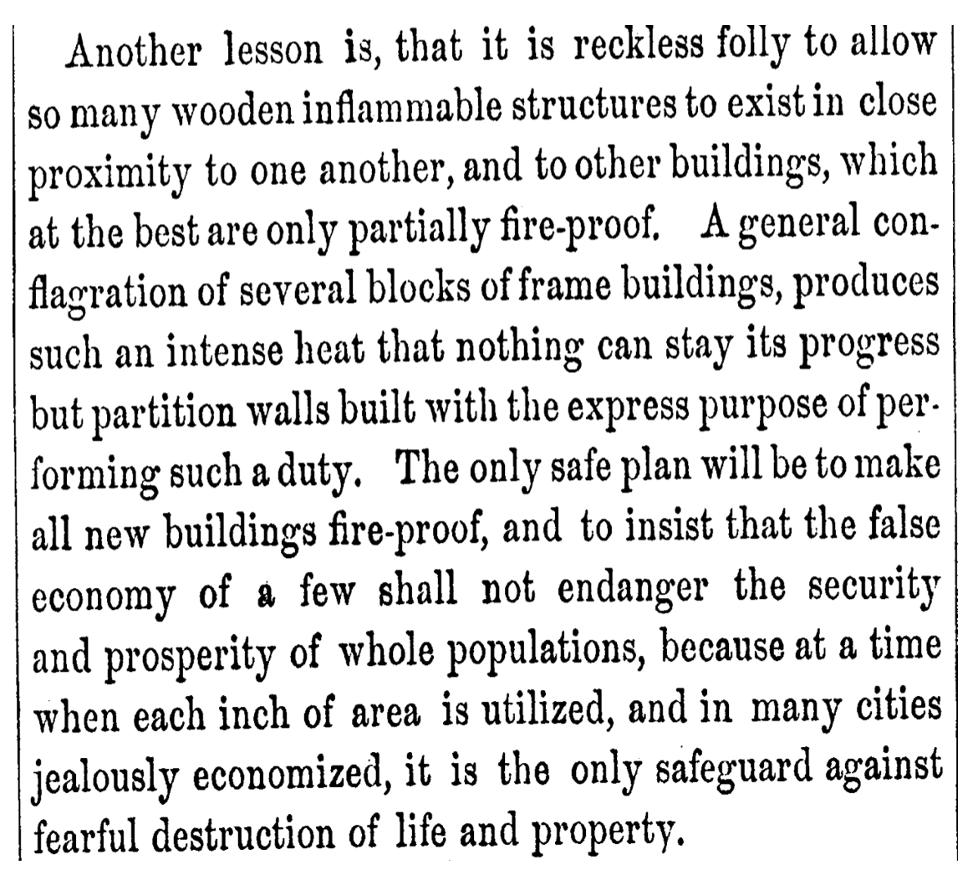
Clue #3 “Excessive Lumber”

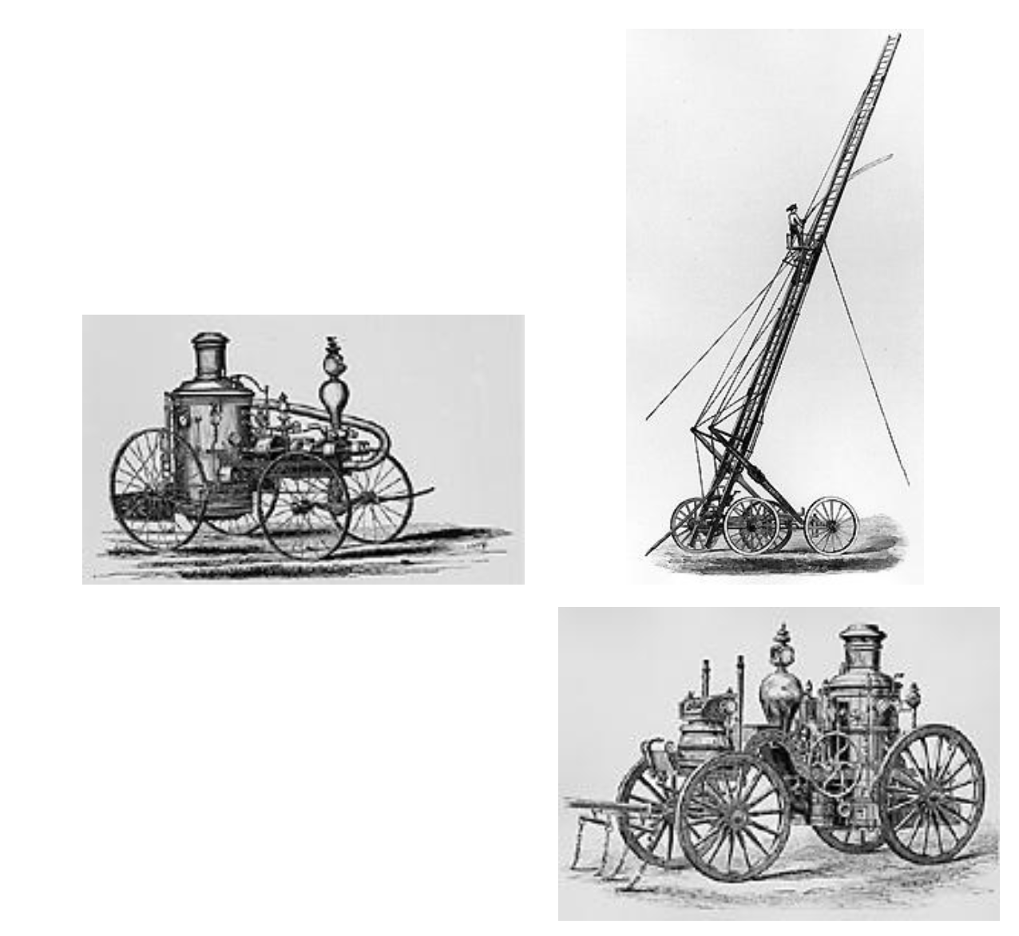
Clue #4 “The Fire Equipment”

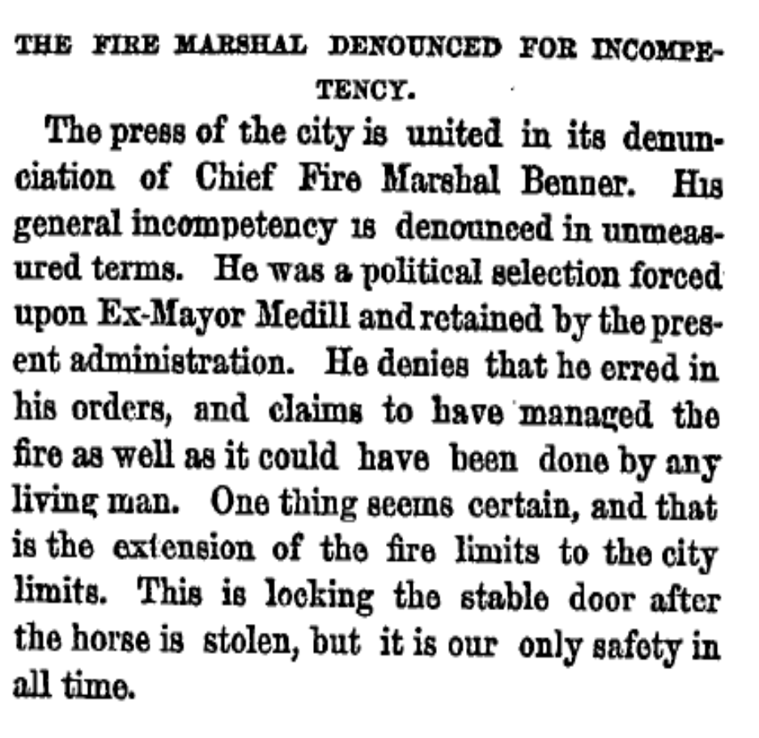
Clue #5 “Blaming the Chief”

Clue #6 “Fire Alarm Malfunction”

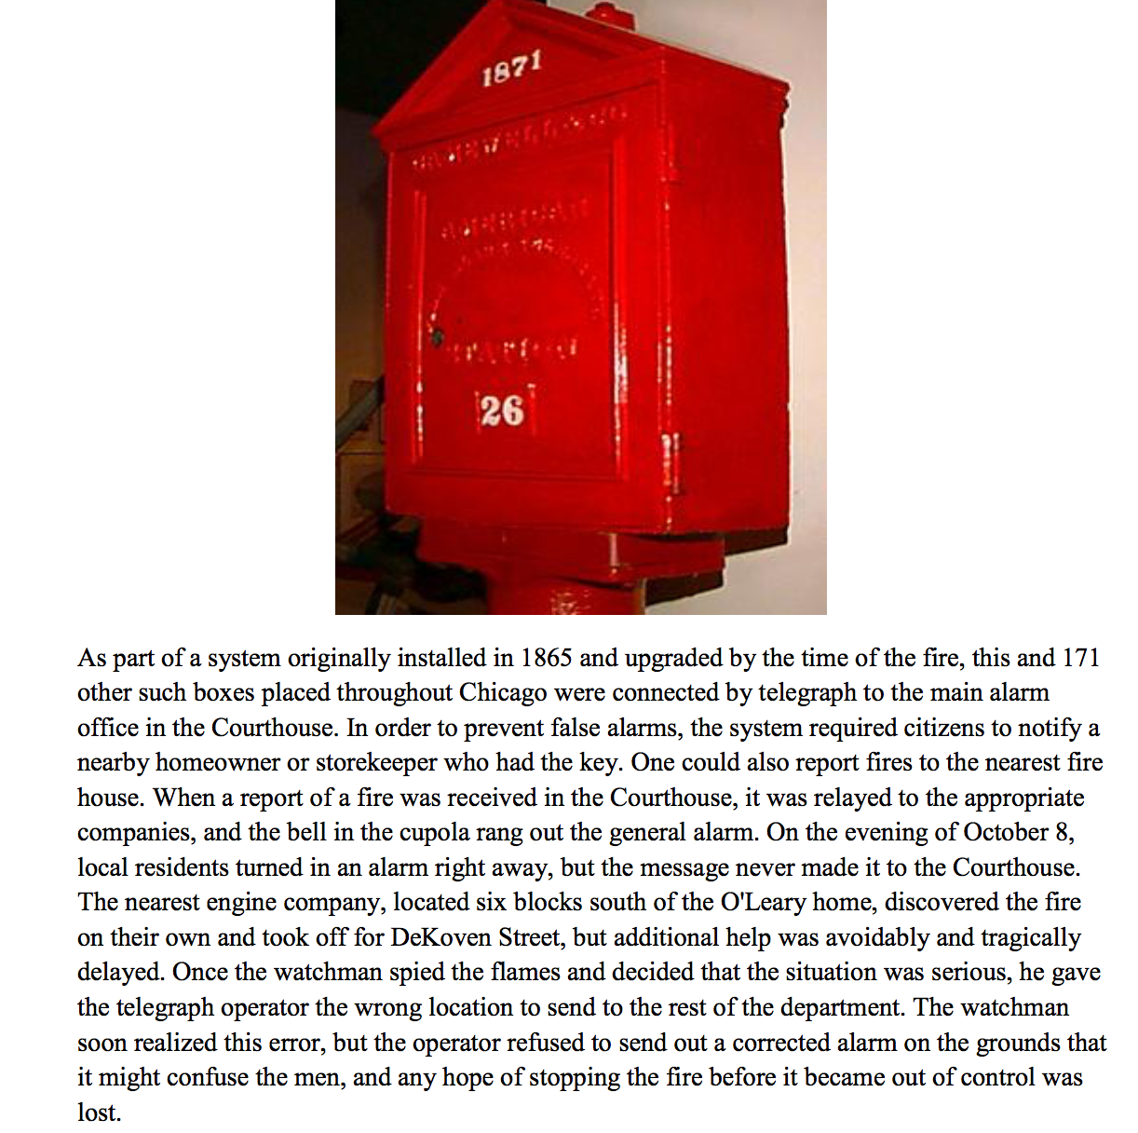

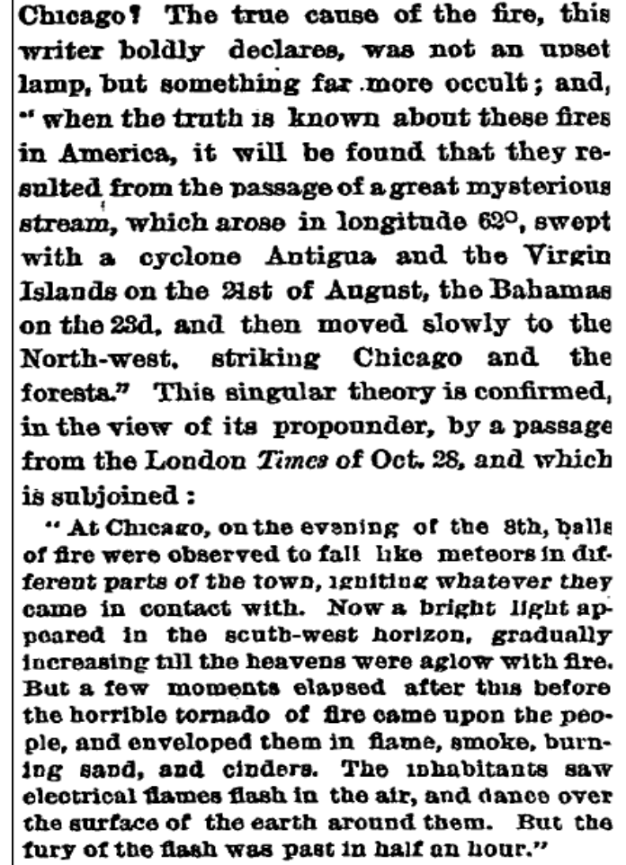
Clue #7 “Meteors”

