Name:_________________________

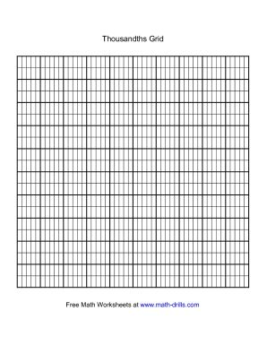Unit 4 Study Guide

Write the following decimals in numerals:

Twenty-five and fourteen hundredths _____________

Nine hundred ten thousandths ______________

Four and seven hundredths ______________

Two tenths ______________

Make the following changes to the number

3.587:

Make the 3 worth $\frac{1}{10}$ as much

Make the 7 worth 10 times as much

Make the 5 worth 10 times as much

Make the 8 worth $\frac{1}{10}$ as much

_______ . _______ _______ _______

Write the following decimals in words:

0.05 __________________________________________________________________________________________________________

3.652_________________________________________________________________________________________________________

________________________________________________________________________________________________________________

9.71__________________________________________________________________________________________________________

_______________________________________________________________________________________________________________

Write the decimal in expanded form and shade the grid.

0.526: ______________________________________________ 0.204: _____________________________________________

______________________________________________________ ______________________________________________________

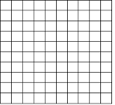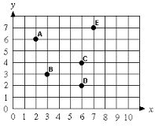

Shade the grid in one color to show the staring number. Then, cross out or shade darker to show the number being taken away. Write the difference to complete the number sentence.

0.52-0.26 = _________________

Write the ordered pairs for the coordinate grids or plot the points.

A: (_______ , _______) F: (9,1)

B: (_______ , _______) G: (0,7)

C: (_______ , _______) H: (10,6)

D: (_______ , _______) I: (5,7)

E: (_______ , _______) J: (2,1)

Round each decimal to the place listed.

|  |  |  |  |
| --- | --- | --- | --- |
| Start Number | Nearest hundredth | Nearest Whole Number | Nearest Tenth |
| 4.024 |  |  |  |
| 6.201 |  |  |  |
| 1.76 |  |  |  |

Write $> = <$ to make the number sentence true.

2.53 ____________ 2.35

1.30 ____________ 1.3

4.051 ____________ 4.015

10.28 ____________ 1.028

Estimate. Then solve for the actual answer.

4.52 + 2.77 = _________________ 10.5 – 3.6 = _________________

Estimate: ___________________________ Estimate: ___________________________

2.99 + 6.31 = _________________ 7.44 – 2. 5 = _________________

Estimate: ___________________________ Estimate: ___________________________

Extra Work Space