Accessing Perspectives and Digits
Students should no longer access these programs through Power School. Please use the following directions to gain access to the accounts.

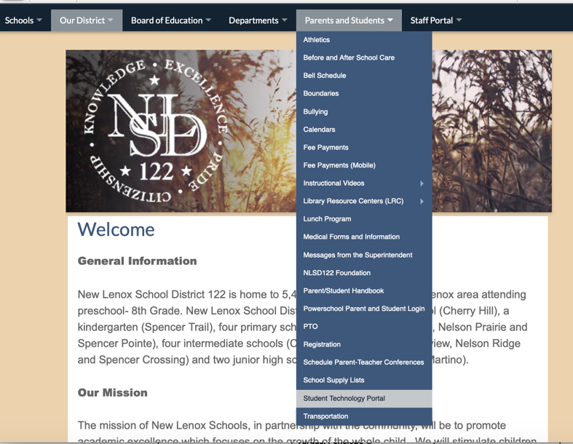
Go to the District’s webpage and click on Parents and Students. Then click on Student Technology Portal.

Once the portal opens, click on Pearson Realize.
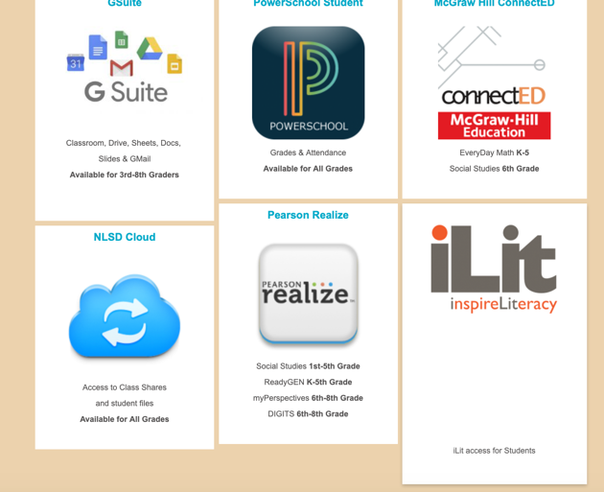

Then enter the appropriate username and password.

Username: 122firstlastname
Password: nlsd+student’s ID #

